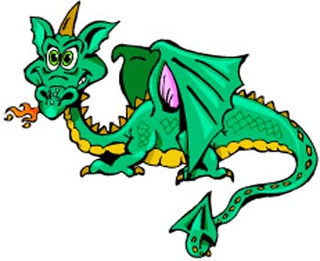
Don District St George’s Day 2018

Group ……………………………………………………..
Could you please fill in and return by 1st April along with your booking form.

FRIDAY SUPPER
 | Beavers | Cubs | Scouts | Explorers | Leaders | Total No
Burgers & Chips
Pizza & Chips
(Veggie)

SATURDAY BREAKFAST
 | Beavers | Cubs | Scouts | Explorers | Leaders | Total No
Bacon Sandwich

Sausage Sandwich

Veggie
Sausage
Sandwich

